**DATABASE MANAGEMENT SYSTEM**

**PROGRAM 1**

**NAME: DEEPIKA P**

**USN: 1NT23CS057**

**CLASS: 4TH SEM A SEC**

**Database Schema for a Student Library scenario**

**Consider that a database named Student Library is developed by an application software NMITSoft company. There are 4 tables in the database. Relationship scheme for the tables is as below:**

**Student (Stud_no : integer,Stud_name: string)**

**Membership (Mem_no: integer,Stud_no: integer)**

**Book (book_no: integer, book_name:string, author: string)**

**Iss_rec (iss_no:integer, iss_date: date, Mem_no: integer, book_no: integer)**

**For the above schema, perform the following**

**a) Create the tables with the appropriate integrity constraints**

**b) Insert around 10 records in each of the tables**

**c) List all the student names with their membership numbers**

**d) List all the issues for the current date with student and Book names**

**e) Give a count of how many books have been bought by each student**

**f) Give a list of books taken by student with stud_no as 5**

**a) Create the tables with the appropriate integrity constraints**

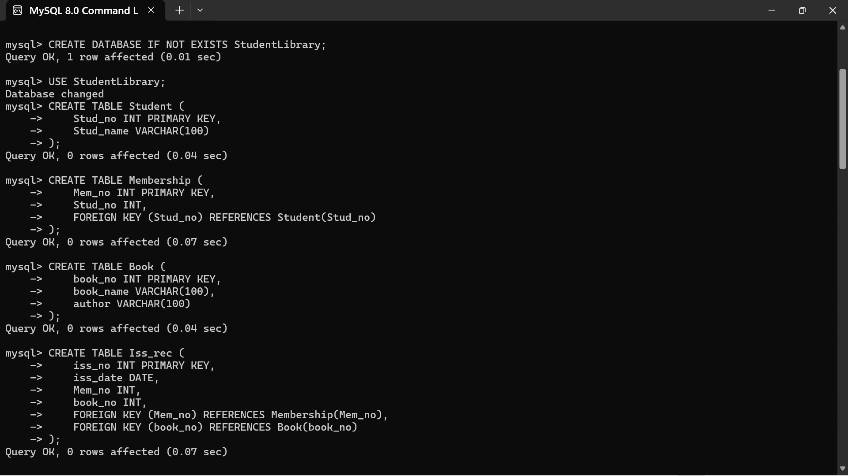

**b) Insert around 10 records in each of the tables**

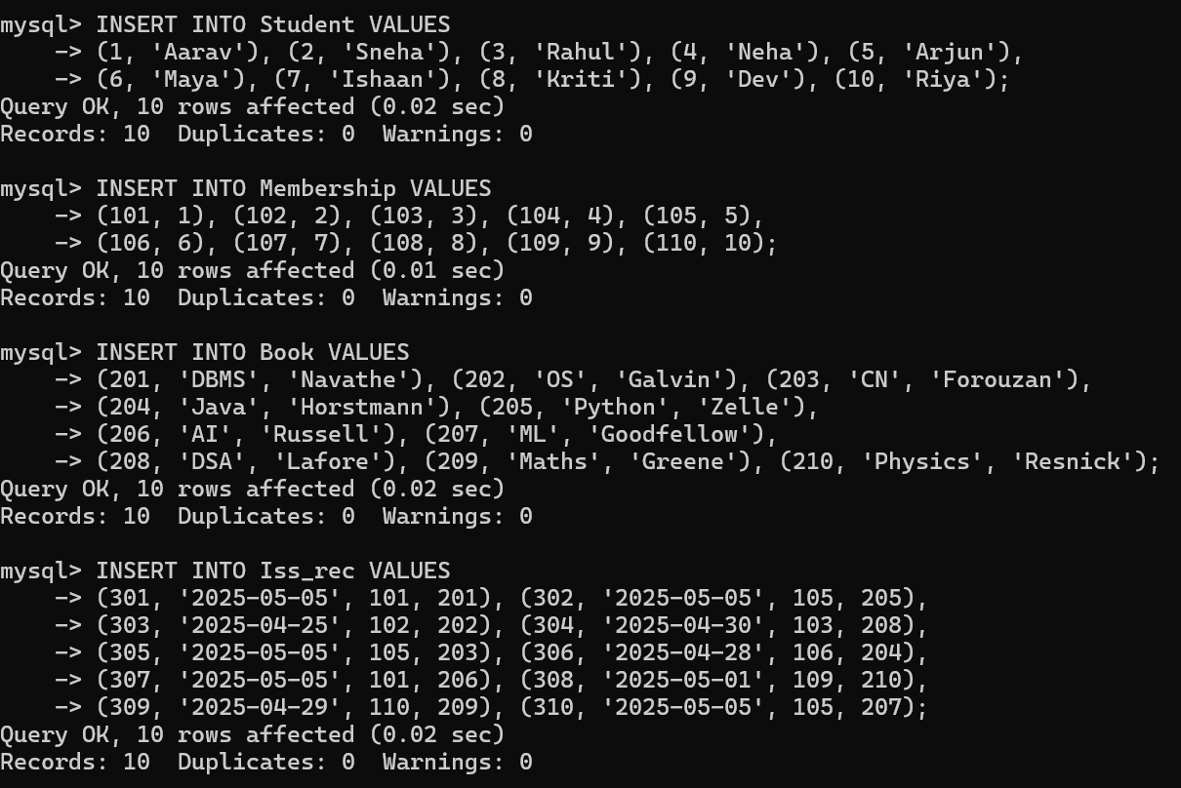

**c) List all the student names with their membership numbers**

**SELECT s.Stud_name, m.Mem_no**

**FROM Student s**

**JOIN Membership m ON s.Stud_no = m.Stud_no;**

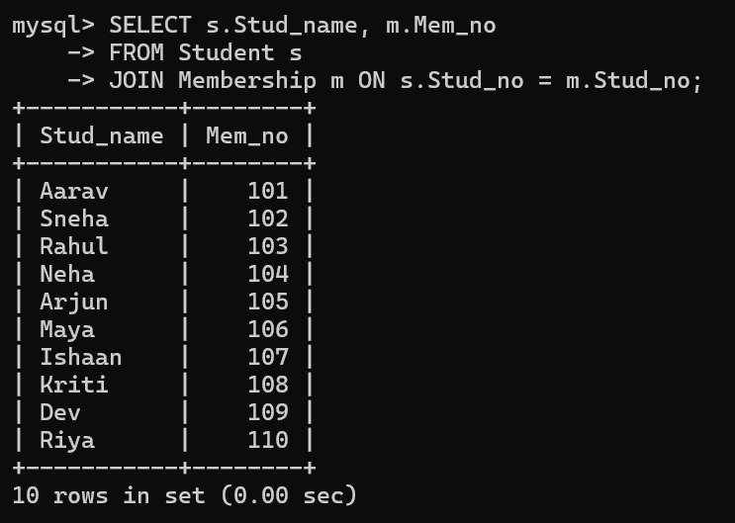

**d) List all the issues for the current date with student and Book names**

**SELECT s.Stud_name, b.book_name**

**FROM Iss_rec i**

**JOIN Membership m ON i.Mem_no = m.Mem_no**

**JOIN Student s ON m.Stud_no = s.Stud_no**

**JOIN Book b ON i.book_no = b.book_no**

**WHERE i.iss_date = '2025-05-05';**

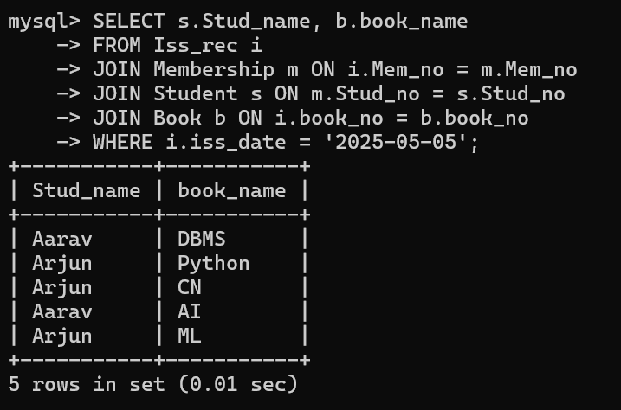

**e) Give a count of how many books have been bought by each student**

**SELECT s.Stud_name, COUNT(*) AS book_count**

**FROM Student s**

**JOIN Membership m ON s.Stud_no = m.Stud_no**

**JOIN Iss_rec i ON m.Mem_no = i.Mem_no**

**GROUP BY s.Stud_no;**

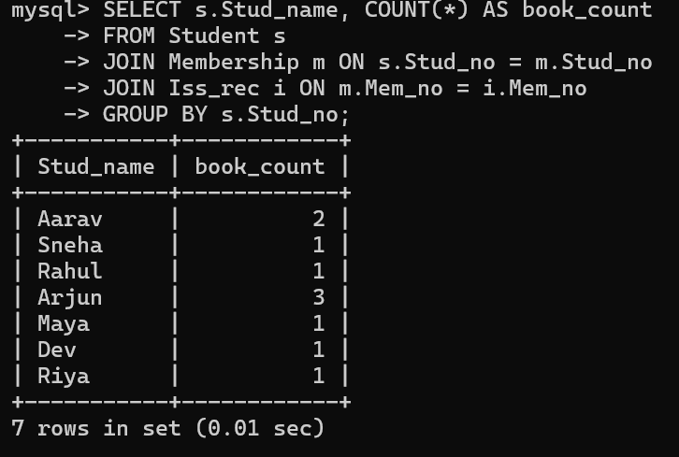

**F) Give a list of books taken by student with stud_no as 5**

**SELECT b.book_name**

**FROM Book b**

**JOIN Iss_rec i ON b.book_no = i.book_no**

**JOIN Membership m ON i.Mem_no = m.Mem_no**

**WHERE m.Stud_no = 5;**

